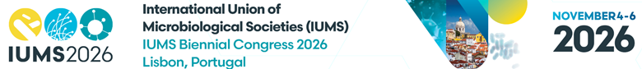IUMS Member Society

Research Excellence Awards

Nomination Form to be completed and sent to Violeta Petrova vpetrova@kenes.com by no later than Midnight CET on Wednesday 29th April

A. Nominee Details
Full name:
Current position and institution:
Country:
Year PhD awarded:
Career interruptions (if applicable):
Email address:

B. Nominating Member Society
Name of Society:
Contact person:
Email:

C. Eligibility Confirmation
- Within 15 years post-PhD (or adjusted)
- Current member of Society
- Able to attend and present in person

D. Research Area and Congress Theme
Primary discipline(s):
Selected Congress theme:

E. Research Summary
Attach 1-page research summary

F. Proposed Presentation Abstract
Submit an abstract by no later than Midnight CET on Wednesday 29th April, 2026 via the link HERE
Once you receive your submission confirmation e-mail including abstract submission number -you can provide this number info this application form below
Abstract Submission Number:

G. Member Society Statement of Support
Describe internal selection process and confirm travel/accommodation support

H. Declaration
I confirm the nominee meets eligibility requirements.
Name:
Signature:
Date:

